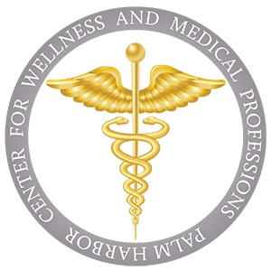  Center For Wellness and Medical Professions | Handbook  2025-2026

Table of Contents
Calendar of Events 3
Event Descriptions: 4
Palm Harbor University High School Mission and Vision Statement 6
Pinellas County Schools Vision, Mission and Core Values 7
Scope and Sequence 8
8
School Profile 9
Completion of the Program 10
Academics 10
Scrubs and Coats: Dress Code for CWMP 12
Volunteer Hours (200 total) 13
CWMP Medical Hours 14
Volunteer Hour Log 15
Clinicals and Shadowing Requirements 18
Clinical Dress Code 19
Probation and Dismissal Process 20
HOSA: Future Health Professionals 22
LPN Program Pathway: Dual Enrollment at Pinellas Technical College (PTC) 24
Requirements To Advance To PTC And To Remain In The LPN Program 26
Additional Resources 29
Contact Information 29
CWMP Booster Club 30
Supporting Student Success Through Involvement 30
Articulation Agreements 32

Calendar of Events
Month | Day | Event | Time | Location | MVH
August | 7 | 9th Grade Orientation | 6:00 – 7:30 PM | Auditorium | 5
 | 5 | Booster Meeting | 6:30- 7:30 PM | Teachers Cafe | 3
 | 26 | Open House | 6:00- 7:30 PM | Auditorium | 5
 | 18 | Fall Fundraiser | 7:30 am | Teachers Auditorium | 10
 | 18 | Class Seminars | 7:30 am | Teachers Auditorium
September | 2 | Booster Meeting | 6:30- 7:30 PM | Teachers Cafe | 3
 | 3 | First Scrub Day
 | 16 | Discovery Night | 6:00-8:00 pm | Auditorium | 3
 | 18 | Med Talks | 6:00- 7:00 pm | Teachers Auditorium | 3
 | 18 | Spirit Day | 7:00 am | Bldg 6
 | 26 | Honor Codes Due |  | CWMP Office
 | 30* | Freshmen Breakfast | 8:00 am | Cafeteria
October | 1* | Advisory Committee | 8:15 am | Teachers Cafe | 3
 | 7 | Booster Meeting | 6:30 pm | Teachers Cafe | 3
 |  | HOSA Fall Leadership Conference | 8:00 am | Rusty Pelican
November | 4 | Booster Meeting | 6:30- 7:30 PM | Teachers Cafe | 3
 |  | FLDA- FL Develop. Lead. Academy
December | 2 | Booster Meeting | 6:30- 7:30 PM | Media Center | 3
 | 6 | Experience PCS | 10:00-2:00 pm | Clearwater High School | 5
 | 17 | Teachers Holiday Celebration | 10:00 am | Room 6-102
January | 6 | Booster Meeting | 6:30- 7:30 PM | Teachers Cafe | 3
 | 7 | Advisory Committee | 8:15 am | Teachers Cafeteria
 |  | HOSA Secondary at Middleton HS
 | 29 | Med Talks | 6:30- 7:30 pm | Teachers Auditorium | 3
 | 30 | Spirit Day | 7:00 am | Bldg 6
February | 3 | Booster Meeting | 6:30-7:30 pm | Teachers Cafe | 3
 | 12 | Glam Run Packet Pick Up | 9:00 am to 12:00 pm | Outside the Cafe
 | 14 | Glam Run | 7:00+ am | Pop Stansell Park | 10+
 | 19 | Junior Pinning | 6:30 – 8:30 pm | Auditorium
March | 3 | Booster Meeting | 6:30-7:30 pm | Teachers Cafe | 3
 | TBD | Freshman Registration Night | 4:00-7:00 pm | Media Center | 6
 | 4 | Advisory Board | 8:15 am | Teachers Cafe
 | 16-22 | Valspar | Various | Innisbrook | 10+
 | 25 | Senior Panoramic | 10:00 | Gym
April | 7 | Booster Meeting | 6:30-7:30 pm | Teachers Cafe | 3
 | 9 | Sophomore Scrubs and Coats | 6:30-8:00 pm | Auditorium | 5
 | 16-19 | HOSA State Competition |  | Orlando
 | TBD | Road to Recognition |  | USFSP | 5
May | TBD | Senior Celebration | 2:00-6:00 pm | Innisbrook | 10+
 | 5 | Booster | 6:30-7:30 pm | Teachers Cafe | 3
 | 6 | Advisory | 8:15 am | Teachers Cafe
 | 7 | Med Talks | 6:30-7:30 pm | Teachers Audit | 3
 | 8 | Spirit Day | 7:00 am | Bld 6
 | 4-8 | Teacher Appreciation |  | Teachers Café
 | TBA | Graduation Rehearsal | 12:00– 1:30 pm | Auditorium
June | 1 | Freshman Meet and Greet | 8:00-1:00 AM | Café | 6

Event Descriptions:
Event | Details
Meet and Greet | A way for new students and parents to learn more about the school and program.
New Student Orientation * | This is an opportunity for new students to visit our campus to learn more about what the school offers and to provide chances to connect with other new students. The purpose of the orientation is to get students acclimated to the campus and to give them a feel for what to expect their first year.
Open House | Open House is an introductory event where guardians can follow their student's schedule. They will meet teachers, gain insight into the classroom experience, and learn about the curriculum. It's an opportunity to connect with us and support your student's academic journey.
Booster Meeting | The Boosters are a group of parents, teachers, and community members dedicated to supporting the school's medical magnet program. They organize fundraisers, provide resources, and aid ensure the success of the program and its students.
Med Talks | Informational sessions organized by the CWMP) at PHUHS. These talks cover various topics related to the medical field, featuring guest speakers, presentations, and discussions aimed at enhancing students' understanding of healthcare careers and industry trends.
Spirit Day | Spirit Day is a special event to foster school spirit and pride within the school community. These days typically involve themed dress-up days, pep rallies, and other activities designed to promote unity and enthusiasm among students, teachers, and staff associated with the CWMP program. Students who participate are recognized or rewarded.
First Year Breakfast | Team building opportunity to welcome students into the program and network with each other.
Advisory Committee | An advisory committee consists of a group of individuals, often parents, students, industry professionals and community members, who provide guidance, feedback, and recommendations to an organization or institution on specific matters. They may meet regularly to discuss issues, review policies, and offer insights to help improve decision-making processes and outcomes. These committees play a crucial role in ensuring that organizations are well-informed and responsive to the needs and interests of stakeholders.
Discovery Night | A night to learn more about a program at a more in-depth level. Each program hosts a Discovery Night on their school campus to give families a feel for the campus and program. Families will learn about the program, meet teachers and students, and get a campus tour.
DAP Fair | DAP Fairs have multiple schools and programs for parents to get a working knowledge of what PCS has to offer. They provide a general overview of the programs and provide materials and handouts to learn more about what they provide. This allows parents to start to narrow down which programs hold their interest.
Teachers Holiday Celebration | An opportunity to honor our teachers for their hard work through the school year.
Glam Run | Networking and fundraising opportunity for the CWMP program.
Booster Meeting | A gathering of booster club members, typically parents, teachers, and community supporters, who come together to discuss and organize activities to support school programs, often related to sports, arts, or other extracurricular activities. The purpose of these meetings is to plan fundraising events, volunteer efforts, and other initiatives that enhance the student experience and provide additional resources for the programs they support.
Sophomore Scrubs and Coats | Team building opportunity to welcome students into the program and network with each other and honor the work the student has accomplished in the program.
Senior Celebration | A night to honor students who will be graduating from the program.

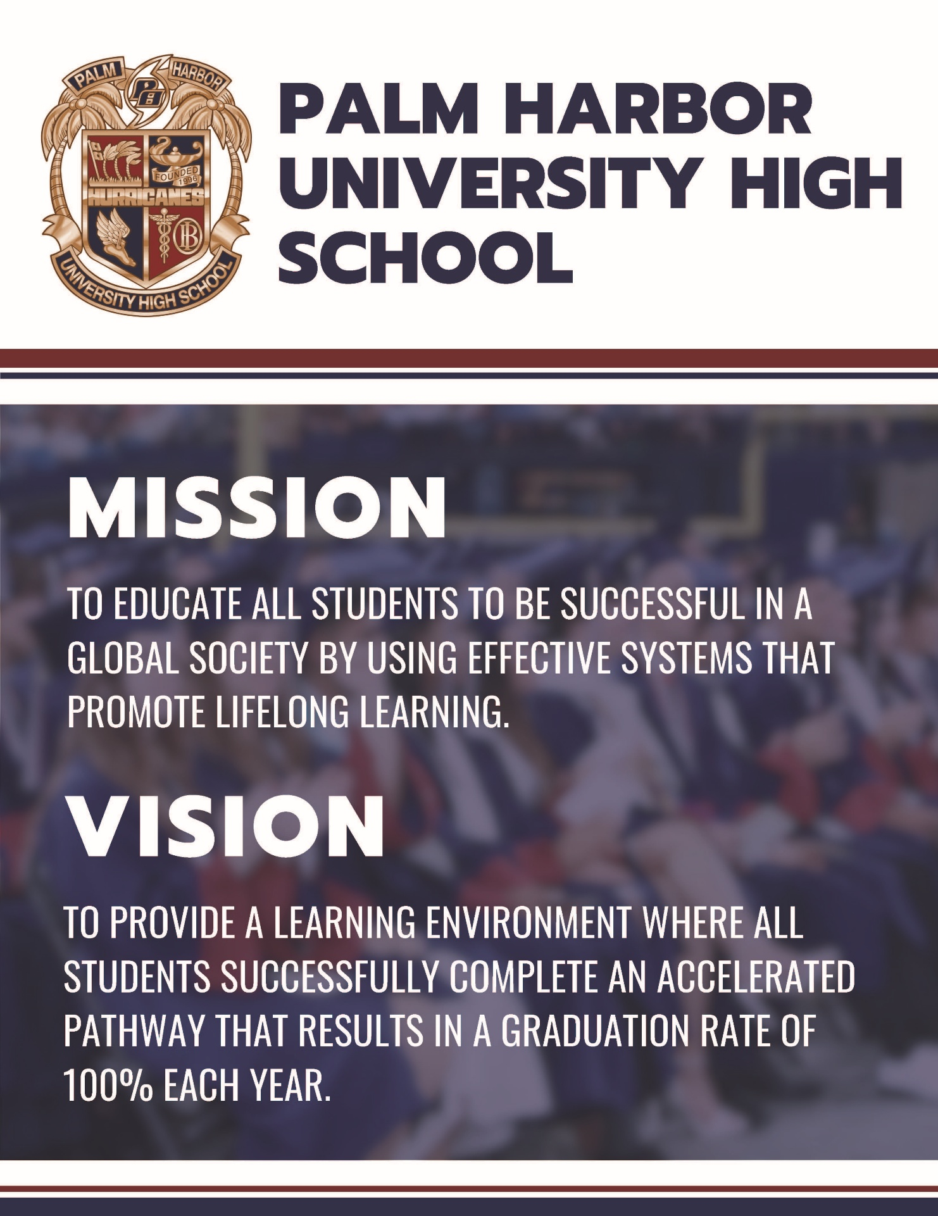
Palm Harbor University High School Mission and Vision Statement

Pinellas County Schools Vision, Mission and Core Values
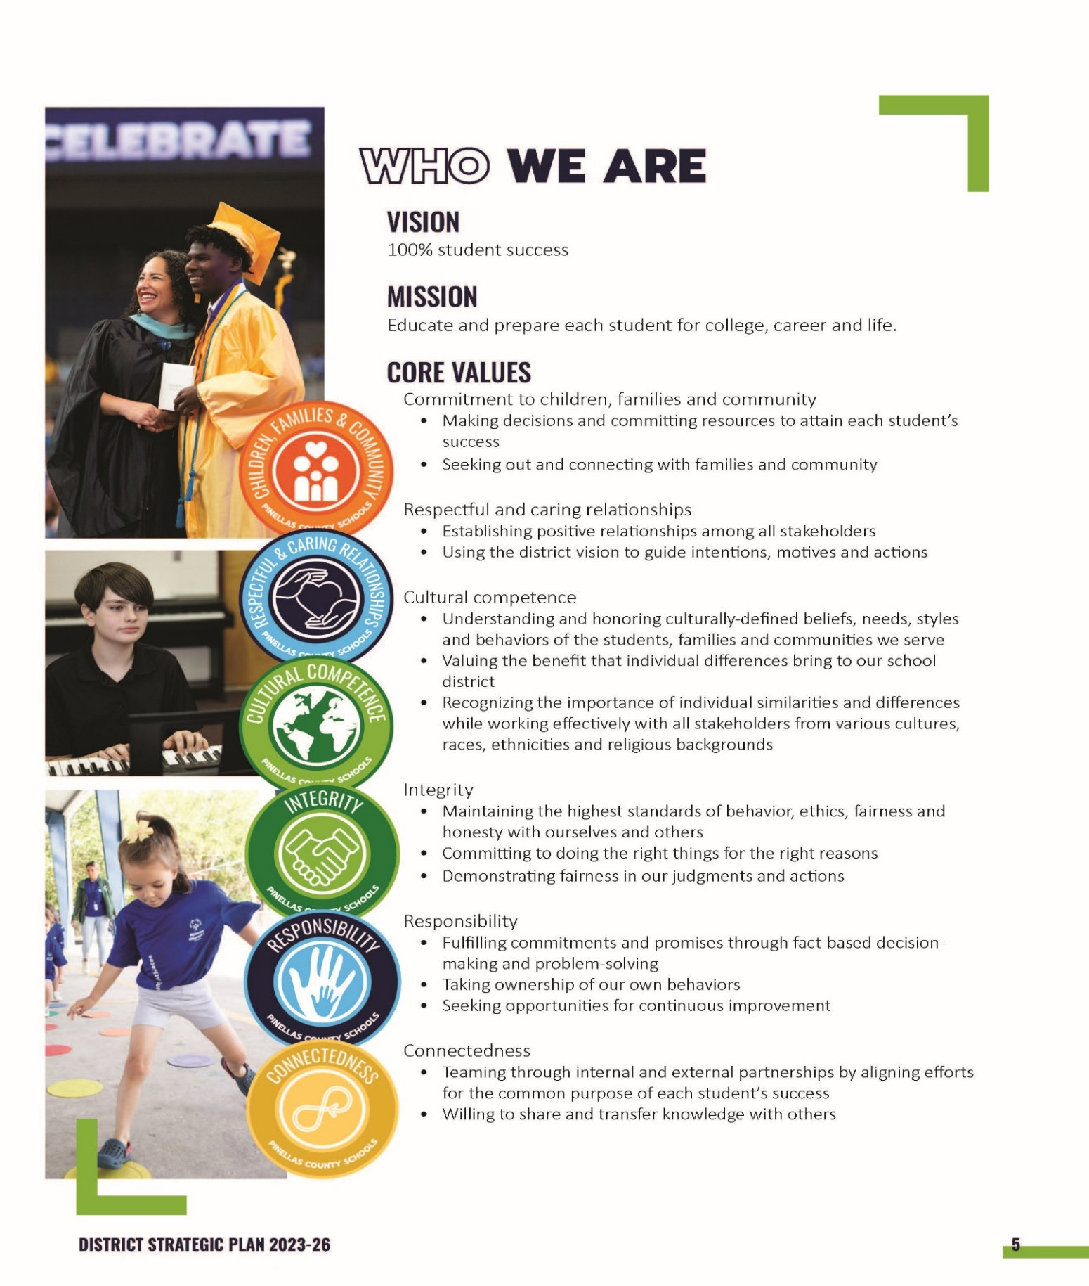

Scope and Sequence

School Profile

Completion of the Program
To successfully complete the Center for Wellness and Medical Professions (CWMP) program and earn graduate with the CWMP, students must meet the following requirements, which reflect the program’s emphasis on academic excellence, professional readiness, and community service:

1. Volunteer Service
- Bright Futures Volunteer Hours: Students must complete a minimum of 100 volunteer hours to qualify for the Bright Futures Scholarship. These hours can be completed in any approved community service setting and must adhere to the guidelines set by the Florida Department of Education.
- Medical-Related Volunteer Hours: Students must complete an additional 100 volunteer hours in a medical or healthcare-related setting. These hours are designed to enhance students' understanding of professional environments and provide meaningful experiences in the medical field.
- Documentation: All volunteer hours must be accurately recorded on approved logs and submitted with supervisor signatures by May 1 of the student’s graduating year. Failure to submit documentation by the deadline will result in ineligibility to graduate with the CWMP Seal.
2. Program Completion Capstone Industry Certifications
- Capstone Industry Certification: To graduate as a PHUHS CWMP program completer students must qualify and take a Capstone Industry Certification exam by the end of their senior year and complete all required medical classes that are relevant to their program of study. The Capstone Industry Certifications listed below are the only qualifying options for program completion.
Biomedical | Pharmacy | Health Care
Biotechnology Aptitude and Competency Exam (BACE) | Certified Pharmacy Technician | Certified Nursing Assistant  License Practical Nurse  Certified EKG Technician  NASM Certified Personal Trainer  Certified Clinical Medical Assistant
- Though additional local and industry certifications are offered for those seeking further credentials. The below certifications do not qualify as a Capstone Industry Certification:
  - First Aid, Cardiopulmonary Resuscitation (CPR), You Science, American Heart Association Basic, Stop the Bleed, Bloodborne Pathogens, Certified Medical Administrative Assistant.

Academics
At the Center for Wellness and Medical Professions (CWMP), academic excellence is driven by high-impact instructional strategies that inspire, challenge, and prepare students for success in the medical field. Our educators are committed to fostering a rigorous and supportive learning environment where students can thrive.

Core Principles
- Engagement from Start to Finish: Teachers meet and greet every student at the door to create a welcoming and respectful atmosphere. This interaction continues as students leave, reinforcing a positive relationship and accountability.
- Building Classroom Culture: Teachers prioritize a supportive environment where students can openly share their thoughts, fostering trust and collaboration.
- Clear Learning Targets: Each class begins with a visible, action-oriented learning target that aligns with state and program standards. These targets guide students in understanding the purpose and outcomes of their lessons.

Instructional Practices
- Variety in Teaching Methods: Teachers design activities that address diverse learning styles, ensuring all students have multiple opportunities to engage with and demonstrate their understanding of the material.
- Collaborative Learning: Daily opportunities for discussion, peer interaction, and content-sharing allow students to deepen their understanding and develop communication skills.
- Mastery Through Assessment: Teachers use formative assessments to monitor progress, identify areas for improvement, and provide targeted reteaching until students achieve mastery.
- Rigor and Critical Thinking: Instruction is built around higher-level questioning and strategic reasoning, encouraging students to think deeply and apply their knowledge to real-world challenges.

Behavior and Mindset
- Positive Behavior Support: Classrooms integrate strategies from the school-wide PBIS plan, reinforcing constructive behavior and a growth mindset.
- Encouraging Innovation: Teachers serve as paradigm shifters, helping students embrace challenges and achieve goals they may have thought were out of reach.

Commitment to Excellence
As Steve Jobs famously said, “The ones who are crazy enough to think that they can change the world are the ones who do.” This philosophy drives our approach to instruction, empowering students to push boundaries and realize their potential.

Scrubs and Coats: Dress Code for CWMP
As part of the Center for Wellness and Medical Professions (CWMP), wearing scrubs or lab coats reflects professionalism and prepares students for real-world medical environments. This dress code policy applies to all juniors and seniors, emphasizing responsibility, consistency, and readiness for clinical and shadowing opportunities.

Uniform Expectations
- Required Days: Juniors and seniors are required to wear the designated scrubs or lab coats on assigned days. The uniform must be worn for the entire school day without alterations or additions.
- Responsibility: Students are responsible for acquiring and maintaining their scrubs or lab coats.
  - Financial Assistance: If a student encounters difficulty purchasing these items, they must promptly inform their medical teacher or program supervisor to explore available support options.

Discipline and Accountability
Failure to adhere to the dress code will result in disciplinary actions.
- First Offense: Warning, teacher-parent phone call, and review of program expectations.
- Second Offense: 45-minute teacher detention, parent phone call, and review of program expectations.
- Third Offense: Extended detention (ABS, 2:00–4:30 PM), restorative assignment, parent meeting, and review of program expectations.
- Fourth Offense: Placement on Behavioral Probation for the Medical Magnet Program.
- Fifth Offense: Potential dismissal from the Medical Magnet Program.
Note: This policy is cumulative throughout the school year.

Temporary Uniforms
- Borrowed Scrubs or Coats: Extra scrubs and lab coats are available for students who forget their uniform.
  - Students must check out a uniform from the medical office upon arrival to school to avoid disciplinary action for a first offense.
  - The borrowed uniform must be returned to the medical office at the end of the school day.

Professional Importance
The scrub and lab coat requirement is integral to the CWMP experience, promoting professionalism, responsibility, and preparation for the healthcare field. Adherence to this policy ensures that students are aligned with the expectations of the medical community and ready for their future roles.

Volunteer Hours (200 total)
Medical Volunteer Hours (100 Hours Required)
- Purpose: Students must complete 100 hours of volunteer service in a medically related setting to gain hands-on exposure to the healthcare field.
- Guidelines:
  - Volunteer hour logs are available online and in the medical office.
  - Hours must be documented on the provided log and signed by the supervisor upon completion.
- Submission Process:
  - Attach a completed “Medical Hour Cover Sheet” to the “Volunteer Hour Log.”
  - Submit the full packet to the CWMP counselor by April 1 of the graduating year.
  - Important: Failure to meet this deadline will result in ineligibility to participate in the graduation ceremony with medical honors.

Bright Futures Volunteer Hours (100 Hours Required)
- Purpose: These hours fulfill the requirements for the Florida Bright Futures Scholarship and must adhere to the guidelines established by the state.
- Guidelines:
  - Hours may be paid or unpaid and can be completed in any approved community service setting.
  - Proper Bright Futures log sheets, available online or in the medical office, must be used for documentation.
- Submission Process:
  - Complete the Bright Futures log with all necessary details and supervisor signatures.
  - Schedule an appointment with the CWMP counselor to submit the completed forms.
  - Deadline: All forms must be submitted by April 1 of the graduating year.
  - Important: Failure to meet this deadline will result in ineligibility to participate in the graduation ceremony with medical honors.

Key Considerations
- It is the student’s responsibility to manage, document, and submit their volunteer hours on time.
- Hours must be completed and logged in accordance with the guidelines provided to ensure acceptance.
- Meeting these requirements not only fulfills program obligations but also builds valuable professional and community engagement experience.

CWMP Medical Hours
Coversheet
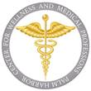

Name:_________________________________________________

Today’s Date:_________________

Current Grade Level: 9th 10th 11th 12th
(circle one)

TOTAL Historical MEDICAL HOURS:_____________________
(Attach all completed medical volunteer hour logs)

I attest I completed these hours and they were completed in an approved medical setting.

Student Signature: _______________________________________________

Date received:_____________________

PHUHS-Center for Wellness and Medical Professions

Volunteer Hour Log

Student Name: ____________________________________________ Student Phone #:_______________________ Student Email:_____________________________________________ Year of Graduation:________________
Name of Agency: ______________________________________________________________________
Date | Agency | Activity | Hours | Signature

Total Hours _______________
Student Signature:_______________________________________________ Date:_______________
(This form is NOT for BRIGHT FUTURES HOURS!!!)

PALM HARBOR UNIVERSITY HIGH SCHOOL
CENTER FOR WELLNESS AND MEDICAL PROFESSIONS (CWMP) HONOR CODE
2025-2026

Welcome to the Center for Wellness and Medical Professions (CWMP), a program dedicated to preparing students for success in rigorous academic and professional healthcare fields. Participation in this program is both a privilege and a commitment to uphold high standards of academic integrity, attendance, behavior, professionalism, and career readiness. This Honor Code serves as a guide for students and parents to align with the core values of excellence, accountability, and integrity essential to the medical and wellness professions.
Academic Integrity
- Commitment to Excellence: CWMP students must demonstrate academic honesty and uphold the principles of ethical behavior. Cheating, plagiarism, or misrepresentation of work will not be tolerated.
- Original Work: Assignments and projects must reflect the student's own efforts. Collaboration is encouraged where appropriate, but individual contributions must be clearly defined.
- Accountability: Academic dishonesty will result in an immediate referral and a grade of 0.

Attendance
- Professional Commitment: Attendance is critical for success in CWMP. Chronic absenteeism, tardiness, or leaving school early disrupts the learning process and jeopardizes skill development.
- Expectations: Students must:
  - Arrive on time and prepared for every class.
  - Notify the school in advance of planned absences or emergencies.
  - Avoid scheduling vacations during instructional time.
- Consequences: Chronic attendance issues may result in intervention plans or probation. Parents are expected to actively support attendance initiatives.

Academic Expectations
- GPA Standards: Students must meet the following unweighted GPA requirements to remain in good standing:
  - 9th Grade: Minimum GPA of 2.0 each semester.
  - 10th Grade: Minimum GPA of 2.3 each semester.
  - 11th and 12th Grades: Minimum GPA of 2.5 each semester.
- Course Grades: Students must pass all courses. Falling below the above GPA expectation will result in academic probation and the development of a success plan.
- Medical Electives: Students who fail their medical elective classes for the year will be immediately dismissed from the CWMP program.
- Bright Futures Volunteer Hours: All students must complete a minimum of 100 volunteer hours as required for Bright Futures scholarship eligibility by graduation.
- Medical Volunteer Hours: In addition to Bright Futures requirements, students must complete an additional 100 hours of medical-related volunteer service to enhance their professional experience by graduation.
- Capstone Industry Certification: Students must qualify and sit for at least one Capstone Industry Certification examination relevant to their program of study.

Biomedical | Pharmacy | Health Care
Biotechnology Aptitude and Competency Exam (BACE) | Certified Pharmacy Technician | Certified Nursing Assistant  License Practical Nurse  Certified EKG Technician  NASM Certified Personal Trainer  Certified Clinical Medical Assistant

Behavior and Professionalism
- Respectful Conduct: CWMP students are expected to model professionalism and respect toward peers, teachers, staff, and community members. Bullying, harassment, or disruptive behavior is strictly prohibited.
- Code of Conduct: All students are expected to follow the Pinellas County Schools Code of Conduct.
- Dress Code: As representatives of the medical field, students must adhere to a professional dress code as outlined in the CWMP handbook. Violations will result in warnings or further disciplinary action.
- Serious Offences: Students who commit serious offences, may be subject to immediate dismissal.

Parental Involvement
- Engagement: Parents are vital partners in their child’s success. Active participation in program events, meetings, and conferences is highly encouraged.
- Support: Parents should encourage their child to meet attendance, academic, and behavioral expectations.
- Responsibility: Parents are expected to uphold the program's guidelines and ensure their child adheres to the Honor Code.
- ClubMed: Boosters: Parents are strongly encouraged to join the boosters yearly to support the events provided to students in each grade level, and through the year: Freshmen Breakfast, Sophomore Scrubs and Coats, Junior Pinning, Senior Celebration and much more.

Consequences for Violations
- Probation: Students who fail to meet academic, attendance, or behavior expectations will be placed on probation, with specific conditions outlined in a success plan.
- Dismissal: Severe or repeated violations of the Honor Code, including failure to fulfill probation conditions, may result in dismissal from CWMP.
- Intervention Process: Students and parents will have the opportunity to address concerns through the Magnet Intervention Committee (MIC) and appeals process.
DISMISSAL
- Students may be dismissed from the CWMP Program for involvement in a disciplinary infraction of a serious nature, such as battery, bullying, fighting, drugs, alcohol, weapon, gang-related activity, and felony arrest.

Acknowledgment
By enrolling in the CWMP program, students and parents commit to upholding the values and expectations outlined in this Honor Code. This agreement reflects a shared dedication to preparing students for the challenges and rewards of the healthcare and medical professions.

Clinicals and Shadowing Requirements
The clinical and shadowing components of the Center for Wellness and Medical Professions (CWMP) program provide students with hands-on experience in professional healthcare settings. Each track has specific requirements and expectations that must be adhered to for successful participation.
- Attendance is Mandatory: Students must attend all scheduled clinicals and shadowing opportunities.
  - Absences: More than six absences (excused or unexcused) per semester may disqualify students from sitting for the Florida Prometric CNA Exam or participating in clinicals. These absences do not carry over between semesters.
  - Tardies: Two warnings will be given; three tardies count as one absence, and four or more tardies result in a referral.
- Judgment and Health: Students must exercise sound judgment about attending clinicals, especially if feeling unwell.
  - Instructors may request a student leave the clinical area if their condition poses a risk to patients, peers, or others. A physician’s medical release may be required for reentry.
- Professional Conduct: Unprofessional behavior during clinicals will result in referrals.
  - After two referrals, students may lose clinical privileges and eligibility for certification exams.
- Academic Standards: A minimum grade of 70% ("C") in both theory and clinical performance is required.
  - Students who fail to maintain this grade will be ineligible to sit for certification exams.

Specific Requirements
- Clinical Competence: Students must demonstrate mastery of clinical skills. If asked to redemonstrate, they must do so successfully to maintain eligibility.
- Skill Confidence: Students are encouraged to ask questions or request double-checks when unsure—ensuring safety is always a priority.

Documentation and Preparation
- Students must meet the following state requirements:
  - PPD (TB) Skin Test (within 30 days of clinical start)
  - Influenza Vaccine (optional)
  - COVID-19 Vaccine (optional)
  - 5-Panel Drug Screen (student/parent responsibility)

Physical and Emotional Requirements
Nursing assisting and clinical work require physical and emotional readiness, including:
- Lifting/Transferring: Up to 75 pounds with assistance.
- Extended Activity: Standing or walking for 90% of shifts.
- Hand-Eye Coordination: Accurate execution of healthcare tasks.
- Emotional Stability: Ability to remain calm and responsible under stress.

Clinical Dress Code
Adherence to the dress code ensures a professional and cohesive appearance in clinical settings:
- Scrubs and Shoes:
  - Approved scrubs with white socks and predominantly white, non-canvas, non-Croc shoes.
  - All attire must be clean, pressed, and professional.
- Grooming:
  - Hair must be tied back neatly and kept a natural color.
  - Beards and mustaches must be trimmed.
  - No strong perfumes or colognes.
- Jewelry and Nails:
  - Minimal jewelry (a watch with a second hand and one pair of small earrings).
  - No artificial nails; nails must be short and unpolished or have natural polish.
- Tattoos: Visible tattoos must be covered.

No-Show Policy
Students must notify the instructor of an inability to attend clinicals by 7:00 AM (earlier is preferred). Failure to do so will result in an automatic referral and potential dismissal from the clinical program.

Probation and Dismissal Process

Academic Probation
Academic probation is determined by a student’s unweighted GPA, calculated at the end of each semester. Students must meet the following GPA requirements to remain in good standing within the Center for Wellness and Medical Professions (CWMP):
Grade Level | Minimum GPA Required
9th Grade | 2.0
10th Grade | 2.3
11th & 12th Grade | 2.5
- Failure to Meet GPA Requirements:
  - If a student fails to meet the required GPA at the end of any semester, they will be placed on academic probation.
  - Students already on probation who fail to meet GPA requirements will face dismissal from the CWMP program.
- Failure of Medical Classes:
  - A failing end of year grade in any medical course will result in immediate dismissal from the program, regardless of the student’s GPA.

Behavioral Probation and Dismissal
Students may be placed on probation or recommended for dismissal for behavior-related infractions, including but not limited to:
- Cheating or academic dishonesty.
- Serious violations such as battery, bullying, fighting, possession or use of drugs or alcohol, weapons, gang-related activity, or felony arrest.
- Continues discipline resulting in 2 or more referrals in 9 weeks.
For serious infractions, immediate dismissal may occur without probation.

Intervention Process
Students not meeting academic, behavioral, or attendance expectations will receive a Magnet Intervention (Success) Plan, developed in collaboration with teachers and administrators. The plan includes strategies and clear expectations for improvement.
If the student fails to meet the goals outlined in their intervention plan, they will be referred to the Magnet Intervention Committee (MIC) for review.

Dismissal Process
- Initial Notification:
Parents and guardians will be informed if their student is not meeting expectations and faces potential dismissal.
- Magnet Intervention Committee (MIC):
  - The committee will review the student's academic or behavioral records and recommend either:
- Final Decision:
  - Dismissals typically occur at transition points, such as the end of a semester or grading period.

Appeal Process
Families have the right to appeal a dismissal decision within 72 hours of notification. Appeals must be submitted in writing to the school principal. The appeal process will follow district guidelines, including a review by the Magnet Intervention Committee and school administration.

HOSA: Future Health Professionals

What is HOSA?
HOSA – Future Health Professionals is an internationally recognized, student-led organization designed for individuals pursuing careers in the healthcare industry. Endorsed by the U.S. Department of Education and the Department of Health and Human Services, HOSA equips students with leadership, technical, and professional skills to excel in their future healthcare careers.

History of HOSA
HOSA was founded in the mid-1970s by forward-thinking leaders in Health Occupations Education.
- 1975: Six charter states met in Cherry Hill, New Jersey, to lay the foundation for the organization.
- 1976: HOSA was officially established during a Constitutional Convention in Arlington, Texas, attended by over 300 student leaders, teachers, and advisors.
- Today: HOSA has grown to over 285,000 members across 3,500 chapters worldwide, including middle school, high school, and collegiate levels.
- Florida HOSA: Established in 1978, Florida HOSA is now the second-largest state association with more than 14,600 members.

Endorsements and Recognition
HOSA is endorsed by several prominent organizations, including:
- The U.S. Department of Education
- The Florida Department of Education
- The Health Science Technology Education Division of the Association for Career and Technical Education
- Over 50 additional health-related partners and industry associations

HOSA’s Role in Education
HOSA operates as an inter-curricular organization, seamlessly integrating into health science education curricula.
- Provides instructional tools, networking opportunities, leadership training, scholarships, and industry connections.
- Offers over 55 competitive events for members to demonstrate their healthcare and leadership skills.

Leadership and Professional Development Opportunities
HOSA members benefit from a variety of events designed to build leadership and professional competencies, including:
- HOSA International Leadership Conference
- Washington Leadership Academy in Washington, D.C.
- HOSA Leadership University
- Florida HOSA Fall Leadership Development Academy
- Florida HOSA State Leadership Conference

Mission
The mission of HOSA is to empower students to become leaders in the global health community through education, collaboration, and hands-on experience.

Purpose
HOSA’s purpose is to develop leadership and technical skills through motivation, awareness, and recognition, forming an integral part of the health science education program.

Why Join HOSA?
HOSA membership offers CWMP students a unique opportunity to:
- Gain leadership experience essential for healthcare careers.
- Participate in competitive events and earn recognition for their skills.
- Network with professionals and peers in the healthcare industry.
- Access scholarships and professional development resources.
- Stand out as a future leader in the global health community.
Participation in HOSA is highly encouraged for all CWMP students. It is a vital step in preparing for a future in healthcare, providing real-world experience and opportunities to excel in this ever-evolving field.

Dates for HOSA 25-266

EXECUTIVE BOARD MEETING DATES | GENERAL MEETING DATES
September 4 | September 10
October 2 | October 8
November 6 | November 12
December 4 | December 10 (+ Holiday Celebration)
January 8 | January 14
February 5 | February 11
March 5 | March 11
April 2 | April 8 (+ End of School Year Celebration)

HOSA VOLUNTEER MEMBERS NEEDED
- August (TBA) – New Student Orientation
- Tuesday, August 26 – Open House/Back to School Night
- September (TBA) – PHUHS Club Fair
- September 16 – Discovery Night
- Saturday, February 14 – Glam Run
- March (TBA) – Registration Night
- Tuesday, March 17 – Sunday, March 22 – Valspar
- Monday, June 1 – Freshman Meet & Greet

Wednesday, September 17
- Membership Deadline
- Letter of Intent to Run for Office Due

Wednesday, September 24
- Chapter #15384 Elections

Friday, October 3
- Suncoast Fall Leadership Conference (FLC), Rusty Pelican, Tampa

Wednesday, October 8
- Competition Sign-up Deadline

Saturday, November 8
- Suncoast Regional Leadership Conference (RLC), Middleton HS, Tampa

Friday, November 14 – Sunday, November 16
- Florida HOSA Fall Development and Leadership Conference (FDLA)

Saturday, January 24
- Suncoast Winter Leadership Conference (WLC)/Regional Competition, Middleton HS, Tampa

Saturday, February 14
- Glam Run

Thursday, April 16 – Sunday, April 19
- Florida HOSA State Leadership Conference, Marriott Orlando World Center

Wednesday, June 17 – Sunday, June 21
- HOSA International Leadership Conference (ILC), Indianapolis

LPN Program Pathway: Dual Enrollment at Pinellas Technical College (PTC)
The Licensed Practical Nurse (LPN) program is a rigorous and rewarding pathway for CWMP students who aspire to begin their nursing careers immediately after high school. Eligible students can dual enroll at PTC to complete the courses required for licensure following successful completion of their junior year at PHUHS.
- Eligibility Requirements
  - To qualify for the LPN Dual Enrollment pathway, students must meet the following criteria:
- High School Graduation Requirements
  - All high school graduation requirements must be completed by the end of their junior year.
- GPA
  - Maintain a cumulative unweighted GPA of 2.5 or higher.
- Course Enrollment & Completion
  - Juniors: Must be enrolled in Anatomy & Physiology or Chemistry.
- Algebra 1 EOC
  - Must have passed the Algebra 1 End-of-Course Exam or a concordant score prior to enrollment.
- Foundations I Course Performance
Students must earn an average of 80% or higher in the Foundations I course at PHUHS.
- TEAS Test Requirement
  - Pass the TEAS exam with a score of 56% or higher within two attempts.
  - The first attempt is covered by PTC; a second attempt, if needed, must be paid for by the student.
- Information Session
  - The student and parent/guardian must attend a mandatory LPN Info Session before acceptance into the program.
- Grading Breakdown – Foundations I LPN Course
  - To ensure consistency and preparedness for PTC coursework, Foundations I grades will follow this breakdown:
- Tests – 70%
- Assignments (ATI, Classwork, Quizzes) – 20%
- Clinical Performance – 10%
Mandatory Summer Session: Foundations II
To transition into the senior-year PTC program, students must attend the Foundations II summer session after their junior year. This session prepares students with the foundational knowledge and clinical skills necessary for the fall dual enrollment experience.

Course Sequence
Juniors:
- Complete Foundations I on the PHUHS campus (2 class periods)
- Attend Foundations II Summer Session at PTC
Seniors:
- Attend PTC Clearwater full-time during the school day
- Courses: Medical/Surgical Nursing I & II and Comprehensive Nursing
Alternative for Seniors (Late Entry):
- Seniors who begin with Foundations I complete the remainder of the LPN program as adult students after graduation (tuition-free for the first term).

Parent & Student Meeting (Spring)
An informational meeting for all eligible juniors and families will take place in late February. Topics include:
- Program expectations and responsibilities
- Transition to college-level learning
- Dual enrollment logistics
- Signing of the contract
- Access to TEAS prep resources (via ATI code)

Requirements To Advance To PTC And To Remain In The LPN Program
It is important for parents and students to know that-
Program Expectations-
- All HS graduation requirements must be met by May of the students’ junior year.
- Attendance during summer hours, from early June to mid-July, is a requirement. Students will begin the Foundations 2 course during the six-week summer session between 11th and 12th grade. Students will attend Monday through Thursday, 7:00am-2:15pm during the summer session.
- Students must take and pass the TEAS exam with a score or 56 or higher. The first attempt TEAS exam will be paid for by PTC. A second and final attempt to reach a minimum score of 56, will be paid for by the parent. The cost of a re-take is $75.00.
- Should a student be unsuccessful in his/her first attempt in the program, he/she will be welcome to return as an adult student to complete the program based on course availability.
- The FLBON application fee must be paid to the Board of Nursing by the parent/student in June of the year of completion. The fee is $110.00.
- Students must keep wireless devices out of sight and on silent or off during class and clinical. This includes smart watches. Most days, students will keep their phones and smart watches at the from of the classroom within instructor view. Students may use devices before and after school. Headphones and earbuds are allowed only before and after school. Wireless devices may be used when directed by a teacher for educational purposes. A teacher shall designate an area for wireless communications devices during instructional time, in accordance with s. 1006.07, F.S.
- Transportation is not provided to the school or to the clinical site.
Grades and Attendance-
- Any grade earned in a course at or through Pinellas Technical College will be posted to students’ high school transcript.
- ALL students must maintain a 90% attendance rate as required by the Board of Nursing.
- Students must earn a minimum grade of 80% in EACH PN courses to be eligible to move forward in the program as required by the Board of Nursing. There will be no remedial opportunities to retake a course as a high school student.
- Tests and assessments are weighted at 70% of a students’ grade in the program. Homework, quizzes and projects are 20% and clinical experiences are 10%.
- As per PTC policy, all absences are considered unexcused. See the PN Handbook for more information on absences.
- Arriving on time and ready to work is a requirement to be successful in the program and is a standard operation procedure of all employers.
Instruction-
- The student will have multiple instructors throughout their time at PTC. This includes didactic learning and clinical experiences.
- This is a work preparation program designed to foster success as a professional nurse. This includes soft skills, communication skills and content skills of the profession.
- The program is taught by professional registered nurses who exhibit the characteristics desired in a professional setting.
- Students will not be given the opportunity to retest or retake exams for any reason including for test correction credit.
- Late assignments are NOT accepted in this program.
- Missing one day of school at Pinellas Technical College is equivalent to missing three days of a double blocked high school class or five days of a single block high school class.
- This is a college course and requires the learning (not just memorizing) of the material. This is not a basic recall course. Students must commit to learning and committing to memory the content. Critical thinking and higher-level thought processes are required to be successful in this program.
- A large portion of the program will be spent in lecture and online learning. This course will require students to dedicate 2-3 hours per evening to study course material.

Clinical-
- Students will be required to drive or provide their own transportation to a variety of clinical sites throughout Pinellas County, including sites from Palm Harbor to St. Petersburg. The meeting times for these clinicals will begin at 6:45AM sharp.
- If a student is not in the designated clinical area by the scheduled start time, the student will have a 10% deduction from their unit clinical grade for each minute late up to 10 minutes (100%). After 10 minutes the student will be sent home from the clinical site, and it will be counted as a clinical absence.
- Students are permitted one clinical absence per course or four clinical absences for the entirety of the program. A missed clinical day will result in a zero daily clinical grade and loss of attendance hours.
- Students will be required (using proper PPE and instructor guidance) to come into contact with, clean up or otherwise address bodily fluids and human waste at the clinical site.
- Students will encounter serious and sometimes disturbing medical situations throughout their time in the clinical setting.
Professionalism/Nursing Code of Ethics
- Students will be taught how to have professional conversations, how to respond professionally in an uncomfortable or unfavorable situation and how to effectively communicate with others. Coaching conversations among other scenarios are used to meet this goal and are documented on coaching forms.
- Students should refrain from interacting on social media with clinical sites and the employees of the sites until graduation. Patient or clinical site photos should never be taken.
- Respectful behavior to all school and clinical site personnel is important to maintain regardless of personal feelings or situations.
- Any behavior impacting the culture and climate of the classroom is not acceptable.
Helpful Recommendations-
- More than one extra-curricular activity or too many work hours are proven to be detrimental to student success in the program.
- Family vacations on scheduled school days are strongly discouraged and are detrimental to student success.
- The rigor of this program is mentally and emotionally taxing. Students who tend to quickly become anxious or struggle to function in highly stressful situations may not yet be ready for the program.
- Students are not provided with breakfast and lunch at PTC. The Culinary program is open 2-3 times per week serving lunch, however there is a cost.

CWMP Communication
- Purpose: Provide families and staff with a comprehensive summary of weekly activities, upcoming events, and key updates related to the CWMP program.

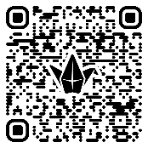
Padlet
- Purpose: Maintain an organized digital bulletin board for quick access to announcements, resources, volunteer opportunities, and program highlights.
- How to Access: Visit the dedicated CWMP Padlet at CWMP Padlet.

Remind
- Purpose: Facilitate direct and immediate communication between program staff, students, and families for reminders, important updates, and time-sensitive announcements.
- Responsible Party: CWMP Program Counselor
- How to Join: Students and parents can join the Remind group by texting the provided code (available through CWMP resources) or downloading the Remind app.

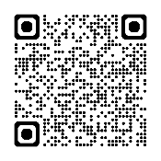
School Website
- Purpose: Serve as the central hub for school-wide and CWMP-specific
- information, including event details, forms, and important dates.
- How to Access: Visit the school website at
- Palm Harbor University High School.

Additional Resources
- CWMP Handbook: A comprehensive guide with detailed information about program policies, requirements, and expectations.
- Weekly Newsletters: Sent every Friday to keep families informed of important updates.
- Volunteer Hour Logs: Available for download on the Padlet and school website.
- HOSA Updates: Shared via Remind, Padlet, and newsletters to ensure students are aware of leadership opportunities and events.

Contact Information
- Office: Jayne Marino marinojay@pcsb.org
- Counselor: Erin Lane laneer@pcsb.org
- Assistant Principal: Diamante Sadlowski Sadlowskid@pcsb.org

CWMP Booster Club

Supporting Student Success Through Involvement
The Center for Wellness and Medical Professions (CWMP) Booster Club is an integral part of our program, fostering a strong sense of community and ensuring the success of our students through financial and volunteer support. By joining the Booster Club, parents and guardians become active participants in their student’s educational journey, helping to create unforgettable experiences during their time in the program.

Why Join the CWMP Booster Club?
- Celebrate Milestones with Purpose:
The Booster Club organizes and funds the major grade-level celebrations that mark key milestones in your student’s academic and professional journey:
  - 9th Grade: Freshman Breakfast – A warm welcome into the CWMP program.
  - 10th Grade: Scrubs and Coats Ceremony – A rite of passage into professional healthcare training.
  - 11th Grade: Junior Pinning Ceremony – Acknowledging students’ dedication and growth.
  - 12th Grade: Senior Celebration – A culminating event honoring students’ accomplishments and readiness to embark on their healthcare careers.
- Enhance Student Opportunities:
Booster Club funds directly support events, certifications, volunteer recognitions, and leadership opportunities, such as HOSA competitions, field trips, and clinical experiences.
- Build a Stronger Community:
Joining the Booster Club connects you with other CWMP families, fostering collaboration and camaraderie as you support your students’ growth. Together, we create a vibrant, supportive environment that strengthens the entire program.
- Lead by Example:
Active parent involvement demonstrates to students the importance of community, commitment, and giving back.

Membership Expectations
While Booster Club membership is not mandatory, it is highly encouraged for all CWMP families. Your participation ensures that each student receives the full benefit of this prestigious program, including:
- Financial support for milestone events and academic enrichment opportunities.
- Volunteer contributions to help organize and run events that bring the CWMP program to life.

How to Join

Visit One of the sites below for instructions.

CWMP Club Med Store | CWMP Club Med Site | Glam Run Site
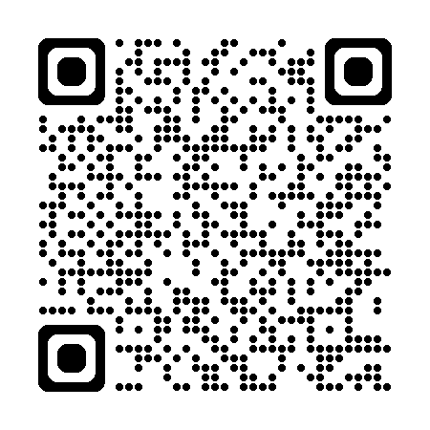 | 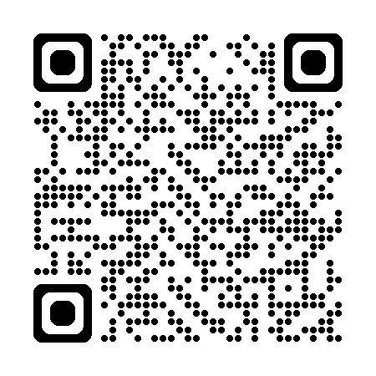 | 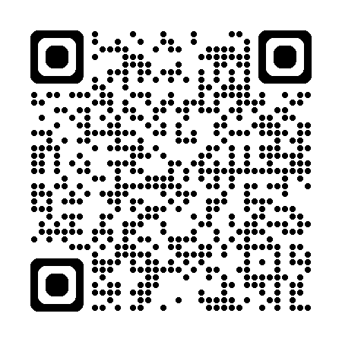
- Membership Fee: A modest annual contribution to help fund key initiatives.
- Volunteer Opportunities: From event planning to day-of assistance, there are many ways to contribute.
- Meeting Schedule: Monthly meetings provide updates on events, funding, and volunteer needs.

Make an Impact Today!
Joining the CWMP Booster Club isn’t just about attending meetings—it’s about ensuring your student has every opportunity to excel and celebrate their hard work. Your involvement is essential to the success of our program and the enrichment of your student’s experience. Together, we can continue to make CWMP a model for excellence in medical education.
Sign up today and help us celebrate every milestone, every achievement, and every success!

Articulation Agreements



Health Science Education

Gain FREE college credit by completing Health Science Education academy courses offered at certain Pinellas County high schools. To potentially qualify for the free SPC credit earn a grade ‘B’, or higher, in all the high school academy courses listed below.
The free credit earned may be used toward any of the Associate in Science degree programs listed below, or it may be applied to general elective requirements for an Associate in Arts degree at SPC.
High School courses | FREE credits at SPC | Cr. | SPC Degrees
Health Science 2 (8417110)  Health Science 1 (8417100)  AND One of the following courses:  Allied Health Assisting 3 (8417131)  OR  Nursing Assistant 3 (8417211) | HSC 1531  Medical Terminology | 2 | Emergency Medical Services A.S. Health Information Technology A.S. Health Sciences A.S.  Physical Therapist Assistant A.S.  Radiography A.S.
Get more details on FREE college credit on our website: spcollege.edu/connect.

Biomedical Sciences

Gain FREE college credit by completing Health Science Education academy courses offered at certain Pinellas County high schools. To potentially qualify for the free SPC credit earn a grade ‘B’, or higher, in all the high school academy courses listed below.
The free credit earned may be used toward any of the Associate in Science degree programs listed below, or it may be applied to general elective requirements for an Associate in Arts degree at SPC.
Get more details on FREE college credit on our website: spcollege.edu/connect.

High School Courses | FREE Credits at SPC | Cr. | SPC Degrees
Principles of Biomedical Science (8708110) | BSC 2420 Introduction to Biotechnology | 3 | Biotechnology Laboratory Technology A.S.
Medical Interventions (8708130) | BSC 2420 Introduction to Biotechnology | 3 | Biotechnology Laboratory Technology A.S.
Students must also successfully pass the Biotechnician Assistant Credentialing Exam (BACE) | BSC 2420 Introduction to Biotechnology | 3 | Biotechnology Laboratory Technology A.S.

